A picture containing clipart

Description generated with very high confidence

Azure 103 Module 4

Hands On - 4

Azure Certification Training

[**support@intellipaat.com**](mailto:support@intellipaat.com)

**+91-7022374614**

**US: 1-800-216-8930(Toll Free)**

**Azure 103 Module 2 , Hands On – 4**

**Upload files in blob storage in storage explorer.**

**Step 1:** Open Blob Container.

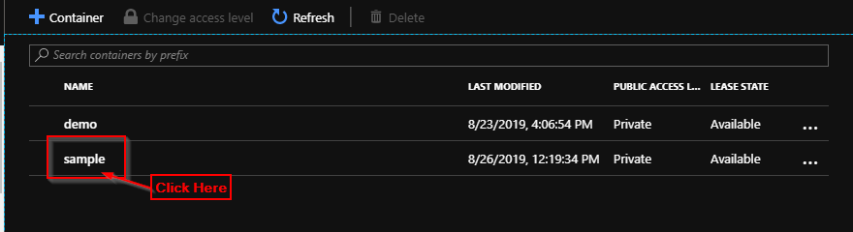

**Step 2:** Click on ‘Upload’.

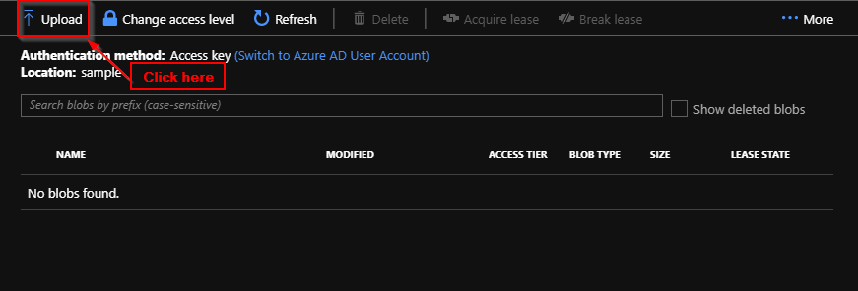

**Step 3:** Select a file.

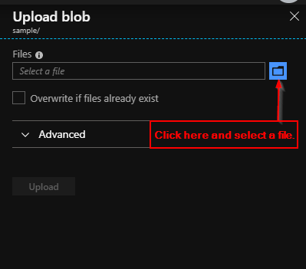

**Step 4:** Click on Upload.

